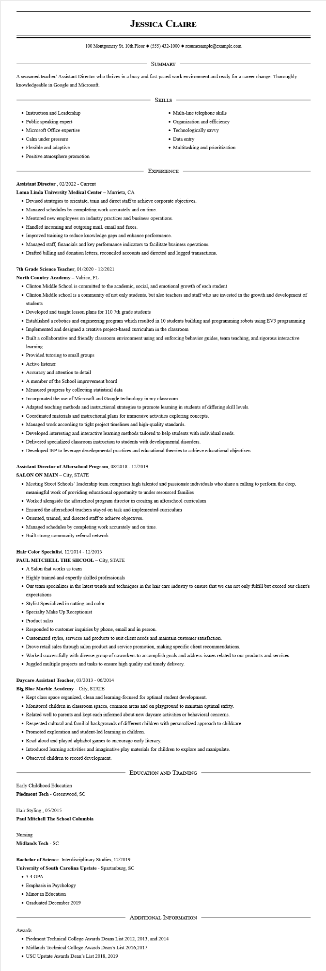
JESSICA CLAIRE
100 Montgomery St. 10th Floor (555) 432-1000◆ resumesample@example.com
SUMMARY
A seasoned teacher/ Assistant Director who thrives in a busy and fast-paced work environment and ready for a career change. Thoroughly knowledgeable in Google and Microsoft.
• Instruction and Leadership
• Public speaking expert
• Microsoft Office expertise
• Calm under pressure
• Flexible and adaptive
• Positive atmosphere promotion
SKILLS
• Multi-line telephone skills
Organization and efficiency Technologically savvy
• Data entry
• Multitasking and prioritization
EXPERIENCE
Assistant Director, 02/2022 - Current
Loma Linda University Medical Center - Murrieta, CA
• Devised strategies to orientate, train and direct staff to achieve corporate objectives.
• Managed schedules by completing work accurately and on time.
• Mentored new employees on industry practices and business operations.
• Handled incoming and outgoing mail, email and faxes.
• Improved training to reduce knowledge gaps and enhance performance.
• Managed staff, financials and key performance indicators to facilitate business operations.
• Drafted billing and donation letters, reconciled accounts and directed and logged transactions.
7th Grade Science Teacher, 01/2020 - 12/2021
North Country Academy - Valrico, FL
• Clinton Middle School is committed to the academic, social, and emotional growth of each student
• Clinton Middle school is a community of not only students, but also teachers and staff who are invested in the growth and development of students
• Developed and taught lesson plans for 110 7th grade students
• Established a robotics and engineering program which resulted in 10 students building and programming robots using EV3 programming
• Implemented and designed a creative project-based curriculum in the classroom
• Built a collaborative and friendly classroom environment using and enforcing behavior guides, team teaching, and rigorous interactive learning
• Provided tutoring to small groups
• Active listener
• Accuracy and attention to detail
• A member of the School improvement board
• Measured progress by collecting statistical data
• Incorporated the use of Microsoft and Google technology in my classroom
• Adapted teaching methods and instructional strategies to promote learning in students of differing skill levels.
• Coordinated materials and instructional plans for immersive activities exploring concepts.
• Managed work according to tight project timelines and high-quality standards.
• Developed interesting and interactive learning methods tailored to help students with individual needs.
• Delivered specialized classroom instruction to students with developmental disorders.
• Developed IEP to leverage developmental practices and educational theories to achieve educational objectives.
Assistant Director of Afterschool Program, 08/2018 - 12/2019
SALON ON MAIN - City, STATE
• Meeting Street Schools' leadership team comprises high talented and passionate individuals who share a calling to perform the deep, meaningful work of providing educational opportunity to under resourced families
• Worked alongside the afterschool program director in creating an afterschool curriculum
• Ensured the afterschool teachers stayed on task and implemented curriculum
• Oriented, trained, and directed staff to achieve objectives.
• Managed schedules by completing work accurately and on time.
• Built strong community referral network.
Hair Color Specialist, 12/2014 - 12/2015
PAUL MITCHELL THE SHCOOL - City, STATE
• A Salon that works as team
• Highly trained and expertly skilled professionals
• Our team specializes in the latest trends and techniques in the hair care industry to ensure that we can not only fulfill but exceed our client's expectations
• Stylist Specialized in cutting and color
• Specialty Make Up Receptionist
• Product sales
• Responded to customer inquiries by phone, email and in person.
• Customized styles, services and products to suit client needs and maintain customer satisfaction.
• Drove retail sales through salon product and service promotion, making specific client recommendations.
• Worked successfully with diverse group of coworkers to accomplish goals and address issues related to our products and services.
• Juggled multiple projects and tasks to ensure high quality and timely delivery.
Daycare Assistant Teacher, 03/2013 - 06/2014
Big Blue Marble Academy - City, STATE
• Kept class space organized, clean and learning-focused for optimal student development.
• Monitored children in classroom spaces, common areas and on playground to maintain optimal safety.
• Related well to parents and kept each informed about new daycare activities or behavioral concerns.
• Respected cultural and familial backgrounds of different children with personalized approach to childcare.
• Promoted exploration and student-led learning in children.
• Read aloud and played alphabet games to encourage early literacy.
• Introduced learning activities and imaginative play materials for children to explore and manipulate.
• Observed children to record development.
Early Childhood Education
Piedmont Tech - Greenwood, SC
Hair Styling, 05/2015
Paul Mitchell The School Columbia
Nursing
Midlands Tech - SC
EDUCATION AND TRAINING
Bachelor of Science: Interdisciplinary Studies, 12/2019
University of South Carolina Upstate - Spartanburg, SC
• 3.4 GPA
• Emphasis in Psychology
• Minor in Education
• Graduated December 2019
ADDITIONAL INFORMATION
Awards
• Piedmont Technical College Awards Deans List 2012, 2013, and 2014
⚫ Midlands Technical College Awards Dean's List 2016,2017
• USC Upstate Awards Dean's List 2018, 2019

